CS610: Final exam (40%)
Due: 05/06/2018, 11:59 P.M.

No delay is accepted whatsoever. After the due date I grade the test for 0
Post your answer in the folder Final Exam on the blackboard.
You can post your answers one time only.
I cannot answer the questions to help you, but if you like to clarify anything about the questions email me at mbadii@pace.edu. In this case let me know which part of a question is not clear for you.

Write your answers in this file below the word: “Answer” and post this file only.
There are two questions.

Question 1 (OpenMP):
Write a parallel program using OpenMp to accomplish the same as the following serial program. For the following serial program the user enters a line and the program outputs the number of occurrences of each character.
For the parallel program if we have n threads we should divide the line into n segments and let each thread counts the characters of its segment.

//File name: a.c
#include <stdio.h>
#include <stdlib.h>
#include <string.h>

#define ASCIIs 127 //ASCII characters from 0 to 127
#define atmost 1000

char letters[atmost + 1]; //Extra location for the string terminator '\0'
int count[ASCIIs];

int main(){
int i, index;

for(i = 0; i < ASCIIs; i++)
count[i] = 0;

printf("Enter a line not larger than 100 characters.\n");
fgets(letters, atmost+1, stdin);//Read a line into array letters. This function adds '\0' to the end of the string

for(i = 0; i < strlen(letters); i++){
index = (int)letters[i];
(count[index])++;
}

for(i = 33; i < ASCIIs; i++)
if(count[i] != 0)
printf("Number of %c is: %d\n", i, count[i]);
return 0;
}
For example:

Enter a line not larger than 100 characters.
for(i = 0; i < strlen(letters); i++){
Number of ( is: 2
Number of ) is: 2
Number of + is: 2
Number of 0 is: 1
Number of ; is: 2
Number of < is: 1
Number of = is: 1
Number of e is: 3
Number of f is: 1
Number of i is: 3
Number of l is: 2
Number of n is: 1
Number of o is: 1
Number of r is: 3
Number of s is: 2
Number of t is: 3
Number of { is: 1

Answer:

Question 2 (Pthread):
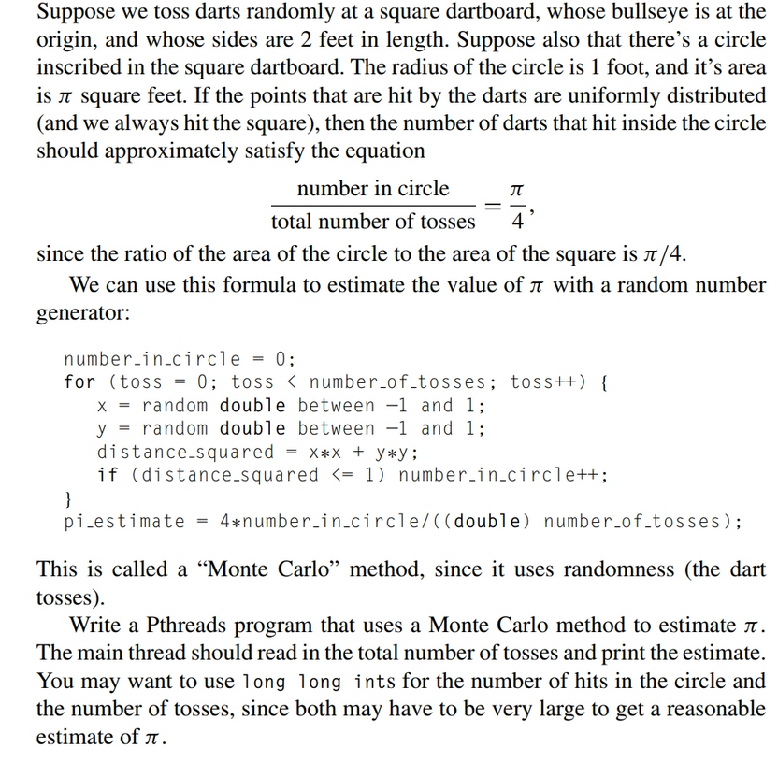

Answer:

